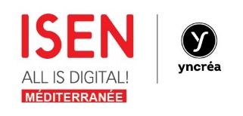 Annex to the Erasmus+ Inter-Institutional
Agreement – Institutional Factsheet

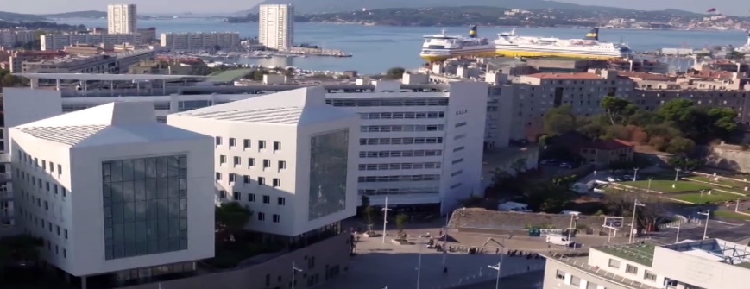

ISEN YNCREA MEDITERRANNE - Institutional Information
Name : |  | ISEN YNCREA MEDITERRANEE – Institut Supérieur de l’Electronique et du Numérique  Campus de Toulon
Erasmus code |  | F TOULON19
Institution Website |  | www.yncrea-mediterranee.fr/international
Course information |  | http://www.yncrea-mediterranee.fr/international
Main contacts
General Director of Yncrea Méditerranée |  | Prof. Didier GOGUENHEIM  didier.goguenheim@yncrea.fr
International Office Contacts |  | Régine BERLIER, Erasmus coordinator  regine.berlier@yncrea.fr  Tel. +33 494 038 954
Head of the Master Cycle |  | Dr. Edith KUSSENER  edith.kussener@yncrea.fr
Head of the Engineering and Biomedical Dpt  (undergraduate level) |  | Dr. Virginie GADENNE  virginie.gadenne@yncrea.fr
Head of Computer Science and Network Dpt  (undergraduate level) |  | Dr. Lidiya YUSCHENKO  lidiya.yuschenko@yncrea.fr
INTERNATIONAL EXCHANGE AGREEMENTS/NOMINATIONS - Contacts
Bilateral agreements |  | Régine BERLIER,  regine.berlier@yncrea.fr
Incoming students - nomination and application documents |  | Régine BERLIER,  regine.berlier@yncrea.fr
Nomination and application procedure
To be done by partner universities
Nomination procedure for Erasmus+ mobility |  | E-mail message including :  Student personal info (Name, surname, birth date, Nationality)  Agreement area  Department of interest  Number of months  Deadlines :  Fall semester/full academic year : June 1st  Spring semester : November 1st
TO BE DONE BY NOMINATED STUDENTS
Application procedure for nominated students | Compulsory documents to be submitted :  Learning agreement (2018-2019 version)  Courses unit list  Transcript of records – academic studies
Registration procedure for nominated students | Registration at the office of the concerned courses to receive :  student card  computer access to the school virtual network  Report to Régine to acknowledge arrival and receive a signed arrival certificate
PRACTICAL INFORMATION
Incoming students (accomodation, visa and residence permit) | Incoming student support office  regine.berlier@yncrea.fr
Academic calender | September 1st to December 22  January 10 to end of June
Language Requirements | No minimum requirements, however, a basic knowledge of the French and English (B1) languages is highly recommended
Programs held in English | Fall at Master level
Courses offered | Engineering courses for 2019-2020 available on line.  A pdf list will be sent to nominated students  For previous academic years :  See doc.2018-2019 isen incoming students
Some general rules must be taken into account when choosing courses :

- Maximum : 30 ECTS/semester
- We allow students to include courses, with a certain degree of flexibility, from all of our major courses but this is subject to assessment and without overlapping of classes
- It is possible to include French courses language course for 2 ECTS
- In order to include a final project in the Learning Agreement, it is necessary to find a supervisor in ISEN.

